CMPS 312 Mobile App Development – Fall 2021

**Assignment 3**

|  |  |
| --- | --- |
| **Student Name** | Mohamed Abdelmoety |
| **Student Id** | 201703976 |
| **Email** | Ma1703976@qu.edu.qa |

**Grading Rubric - - In the *Functionality* column please specify either: *Working (completed x%)*, *Not Working (completed x%)* or *Not done*.**

|  |  |  |  |  |
| --- | --- | --- | --- | --- |
| **Criteria** | **%** | **Functionality\*** | **Quality of the implementation** | **Student Score** |
| **List Account by type [Saving, Current , All]** | 40 |  |  |  |
| **Delete Account** | 10 |  |  |  |
| **Add account with Navigation** | 25 |  |  |  |
| **Update Account with Navigation** | 25 |  |  |  |
| **Total** | **100** |  |  |  |
| **Not uploading Testing Sheet with screenshots** | **-15** |  |  |  |
| Copying and/or plagiarism or not being able to explain or answer questions about the implementation | -100 |  |  |  |

**Possible grading for functionality**:

* ***Complete and Working*** (get 70% of the assigned grade),
* ***Complete and Not working*** (lose 40% of assigned grade)
* ***Not done*** get 0.
* The remaining grade is assigned to the quality of the implementation.
* Must submit screenshots in this **Testing-GradingSheet.docx** (otherwise - 15pts).

Accounts List

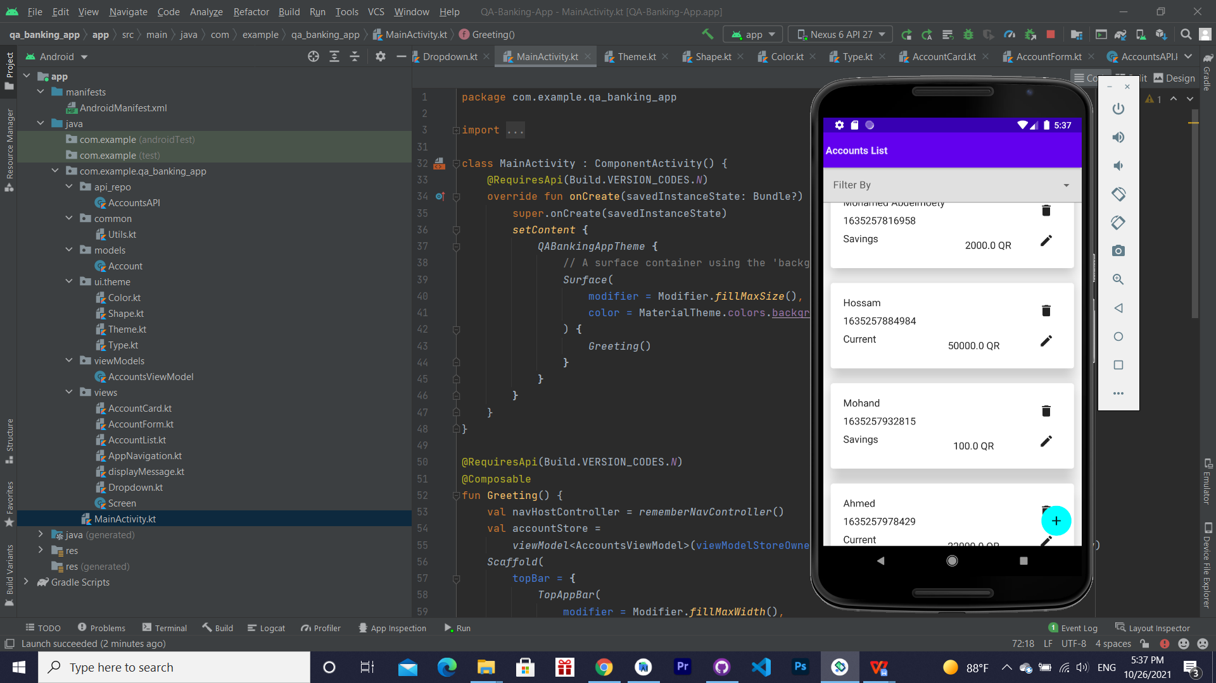

Add Account

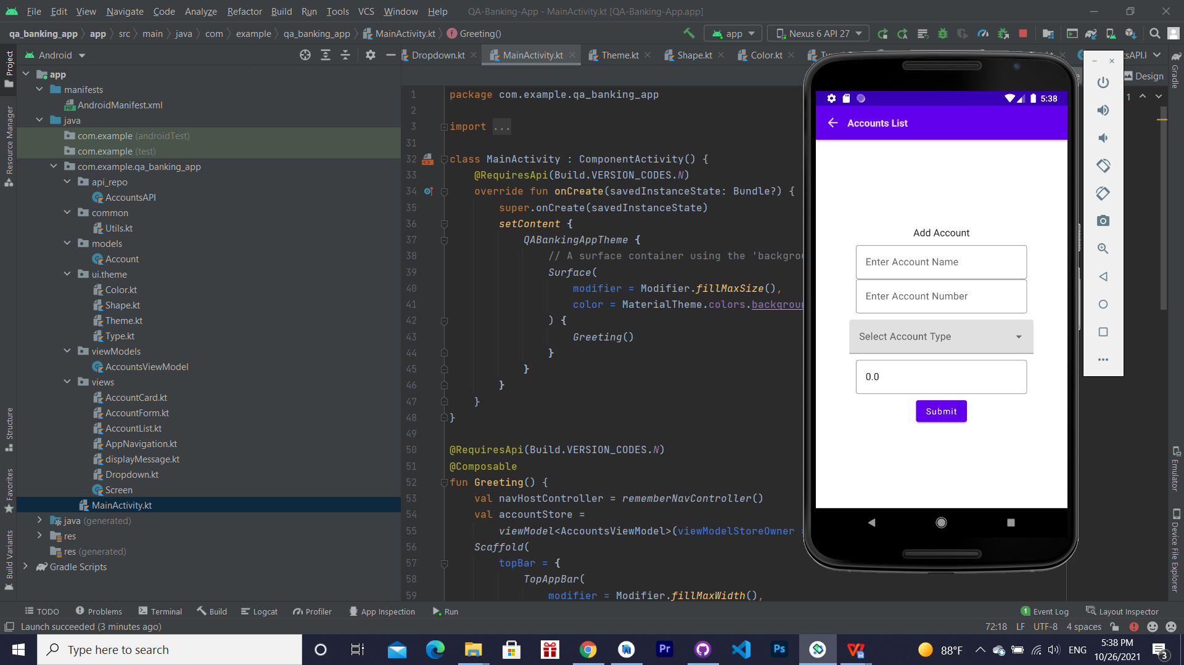

Edit Account

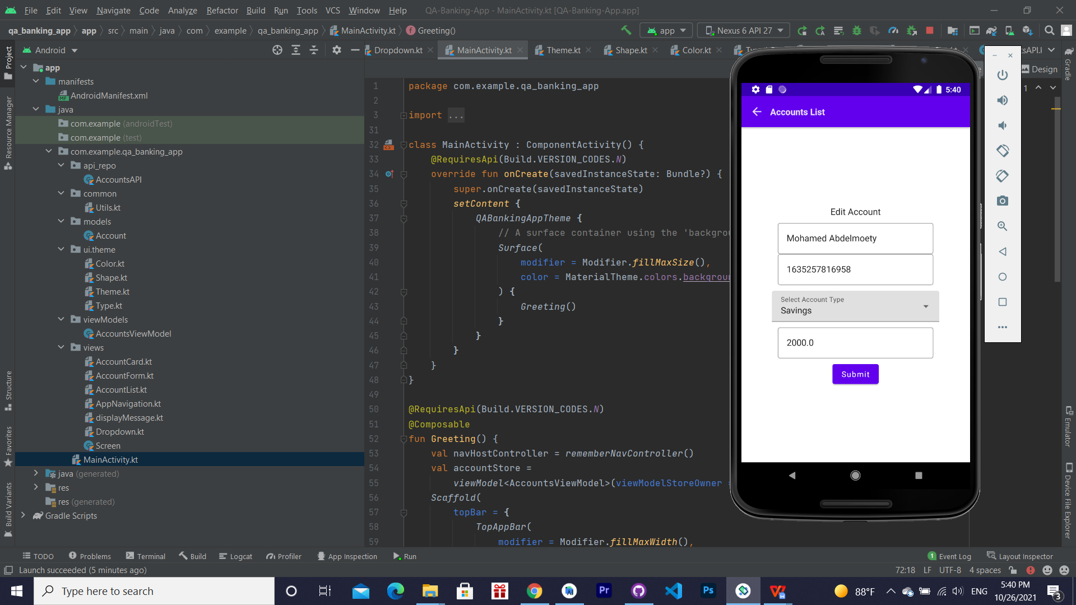

Delete Account (Hossam Account(It’s Appear in 1th screenshot))

